Deep learning : to find the steering angles & self-braking

**Introduction:**

Autonomous driving has been talked about for a long time, and with the rapid increase in artificial intelligence technology many semi-autonomous features are already built in today’s car. For example, assistance in car parking and automatic gear change and self-brake system.

An autonomous vehicle operates without any human interaction and more on the data & behavior analysis that is already fed inside the system. Autonomous driving is a game changing theory which is not fully implemented but if it does its going to be adding much more benefits to our lives. Like observant sensors would result in much more intelligent and simultaneously less accidents. Besides it can also scan multiple directions and don’t forget about planning the drive through shortest way possible. Traffic analysis and there’s whole different world to it.

As much as the idea of autonomous cars fascinates our human mind there is some drawback to it as well and that’s where we want to contribute. The project will be divided in to two parts

1. Finding a steering Angle
2. Self-Breaking

**Proposal:**

1. **Finding a steering Angle**

In order to make the movements efficient and intelligent we will finding steering angle from all aspects.

* With the help of Python and Open CV lane lines would be detected to avoid any collision.
* Dataset of manually driven cars would be added for simulation on the basis of which vehicle will drive itself.
* 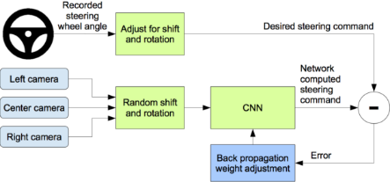Using NIVIDEA project we will use the following model

1. **Self-Breaking**

Using computer vision methods traffic signs would be read and actions would be applied based on the signs.